Amrutvahini Sheti and Shikshan Vikas Sanstha’s

**AMRUTVAHINI POLYTECHNIC, SANGAMNER**



**CERTIFICATE**

**This is to certify that**

|  |  |
| --- | --- |
| **Roll No** | **Name** |
| 23 | Shaikh Nastayeen Feroz |
| 27 | Pawar Sonali Machindra |
| 31 | Thorat Rinku Vijay |
| 39 | Aghav Shetal Sanjay |

**Has satisfactorily completed Micro-Project work entitled,**

|  |  |
| --- | --- |
| **Prof. Bhabad V.M.** | **Prof. Kale G. B.** |
| **(Subject Teacher)** | **(H.O.D)** |

**“Voting Management System”**

**As prescribed by MSBTE, Mumbai as part of syllabus for the partial fulfillment in Diploma in Computer Technology for Academic Year 2019-20**

**Annexure-II**

**Micro-Project Report**

**VOTING MANAGEMENT SYSTEM**

1. **Rationale**

Voting management system is beneficial for the management of Voting and as a software it will help in developing professionalism, a platform for voting simply and securely.

1. **Aims/Benefits of the Micro-project**

To develop Voting Management Software.

1. **Course Outcomes Achieved**
2. Use Visual Studio IDE to design application.
3. Develop GUI Application using Form control and its Events.
4. Apply Object Oriented concept in GUI application.
5. Use data access control to store data in database and retrieve it.
6. **Literature Review**

The main advantage of Voting Management System is dynamic Management software. This software is ideal for voting management. This software Manage Database, Admin Login and Candiate names with photos panel like never before. Organize Voting management and Build Database.

1. **Actual Methodology Followed**

Voting management system is developed with functionalities such as admin login, Menu, Voting panel, Result.

This software also provide an Build Database.

**Admin Login:**

In this section admin can login. This is main page providing personalized access and services to admin. Admin login is also the first form to be displayed. When admin is logged in succesfully then voting starts. Admin credentials will be verified with database table login.

**Voting Panel:**

In this section voter can vote to the candidate. In this section voter can see the candidate name with the photo of candidate. Voter can vote using voter id and voter should be verified by database. There is no duplicate voter id is available. In this section their is a button to vote particular candidate. In this form voter can see the remaining time for voting. When time is up the voting panel automatically closed. When voter click on submit button then voters vote will be submitted in database.

**Menu:**

This section appears after the admin login. In this section there are two option for admin one is to start voting system and another one is view result. Start voting system is to start the voting panel and view result is to view the voting result.

**Emergency Exit:**

When there is problem in voting time admin can logout emergency. So there is option to exit voting system. Admin can exit voting system using the credienatials that are verified form the database.

**View Result:**

In this section admin can see the voting results.This count voting at that time when admin wants. Its not working like before systems. It generates result very fast.

|  |  |  |  |
| --- | --- | --- | --- |
| **S.**  **No.** | **Work done** | **Description** | **Responsible Team Members** |
| 1) | Project Initialization | Requirement gathering | Shaikh Nastayeen. |
| 2) | Project Planning | Scheduling,  Time management | Pawar Sonali. |
| 3) | Modeling | Basic Design | Thorat Rinku. |
| 4) | Construction | Coding | Padoli Shravani. |
| 5) | Documentation | Testing,  Report Generation | Aghav Shetal. |

1. **Actual Resources Used**

|  |  |  |  |  |
| --- | --- | --- | --- | --- |
| **S.**  **No.** | **Name of Resource/Material** | **Specification** | **Qty.** | **Remarks** |
| 1) | Operating System | Windows 10 | 01 | - |
| 2) | Development Tool | Visual Studio | 01 | - |
| 3) | Database | MS ACCESS | 01 | - |
| 4) | Reference Website | [www.youtube.com](http://www.youtube.com/) | 01 | - |
| 5) | Operating System | Windows 10 | 01 | - |

**7.0 Outputs of the Micro-Project**

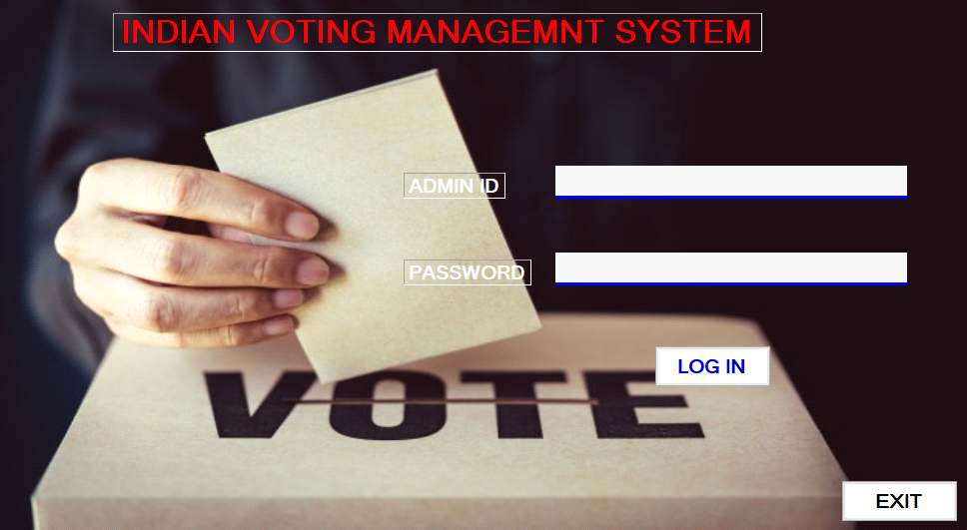

**Admin Login**

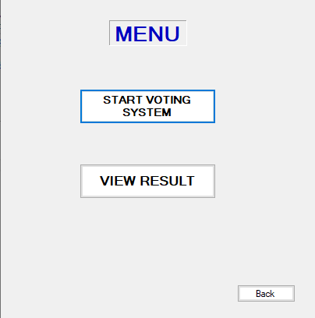

**Menu**

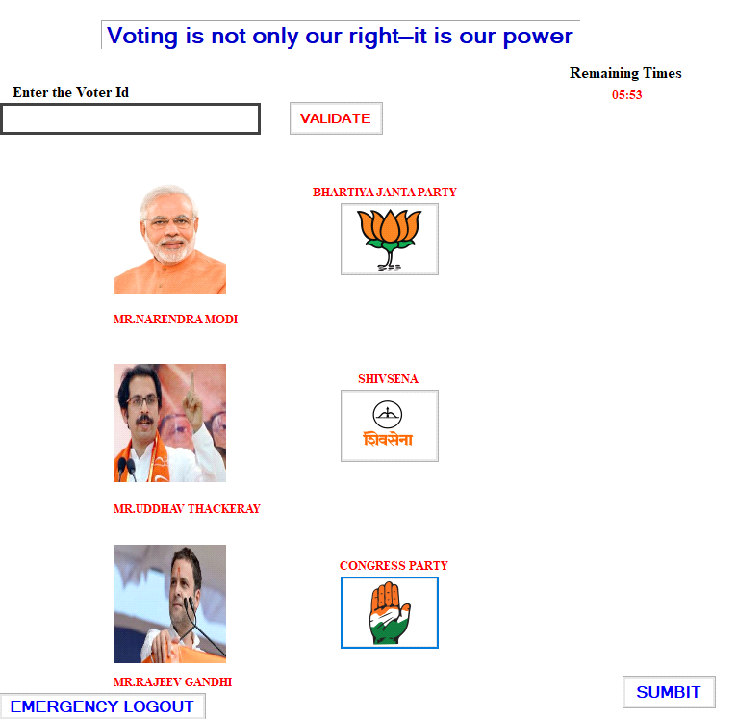

**Voting Panel**

1. **Skill Developed/Learn Outputs of the Micro-Project**
2. Create event handler to respond to given event.
3. Use the given form control in VB.NET application development.
4. Select relevant data type for the given problem with justification.
5. Implemented Database connectivity.
6. **Applications of this Micro-Project**

It can be used by the government for voting as well as collges, industires and anywhere there voting system is appear.